DB-Assign_7-DatabaseDesign-BrenoJoseGomesDeSouza-23F

Part 1:

A:

CREATE DATABASE Game_blog;

B:

CREATE TABLE AuthorsTable (

Author_ID INT NOT NULL AUTO_INCREMENT PRIMARY KEY,

Author_Name VARCHAR(25),

Email VARCHAR(225),

Bio TEXT,

Username VARCHAR(25)

)

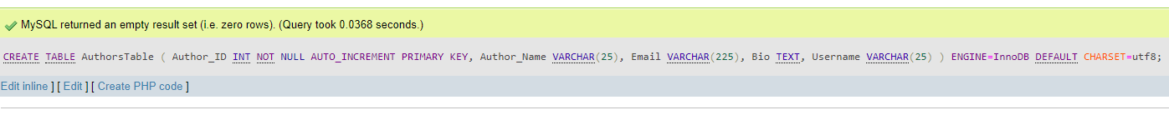ENGINE=InnoDB DEFAULT CHARSET=utf8;

CREATE TABLE PostTable (

Post_ID INT NOT NULL AUTO_INCREMENT PRIMARY KEY,

Author_ID INT,

Post_Title VARCHAR(225),

Post_Content TEXT,

Post_Date DATETIME

)

ENGINE=InnoDB DEFAULT CHARSET=utf8;



Part2:

A:

CREATE TABLE Comments (

Comment_ID INT NOT NULL AUTO_INCREMENT PRIMARY KEY,

Author_ID INT,

Post_ID INT,

Comment_Text TEXT,

Comment_Date DATETIME,

FOREIGN KEY (Author_ID) REFERENCES AuthorsTable(Author_ID),

FOREIGN KEY (Post_ID) REFERENCES PostTable(Post_ID)

)

ENGINE=InnoDB DEFAULT CHARSET=utf8;

B:

INSERT INTO Comments (Author_ID, Post_ID, Comment_Text, Comment_Date)

VALUES

(1, 1, 'Consectetur adipiscing elit', '2024-02-23 10:15:00'),

(2, 2, 'Dolor sit amet', '2024-02-24 09:30:00'),

(1, 1, 'Lorem Ipsum', '2024-02-25 15:45:00');

Part3:

A:  
Since I created the table with the column “comment_date” in part 2 A it will give me an error:  
  
Instead of it, I’ll take the liberty of updating the comments table by adding a new column called “comment_status”:

UPDATE Comments SET Comment_Status = 'Approved' WHERE Comment_ID = 1;

UPDATE Comments SET Comment_Status = 'Pending' WHERE Comment_ID = 2;

UPDATE Comments SET Comment_Status = 'Approved' WHERE Comment_ID = 3;

B:  
First I inserted new data on both tables->  
AuthorsTable:

INSERT INTO AuthorsTable (Author_ID, Author_Name, Email, Bio, Username)

VALUES

(123, 'Lorem Ipsum', 'LoremIpsum@loremipsum.com', 'Duis aute irure dolor in reprehenderit', 'lorem123'),

(456, 'Dolor amet', 'Doloramet@loremipsum.com', 'In voluptate velit esse cillum dolore', 'dolor456'),

(789, 'Excepteur sint', 'Excepteursint@loremipsum.com', 'Eu fugiat nulla pariatur.', 'excepteur789');  
  
Post table :  
INSERT INTO PostTable (Author_ID, Post_Title, Post_Content, Post_Date)

VALUES

(123, 'Lorem Ipsum Title', 'Duis aute irure dolor in reprehenderit', '2024-02-23 10:15:00'),

(456, 'Dolor Amet Title', 'In voluptate velit esse cillum dolore', '2024-02-24 09:30:00'),

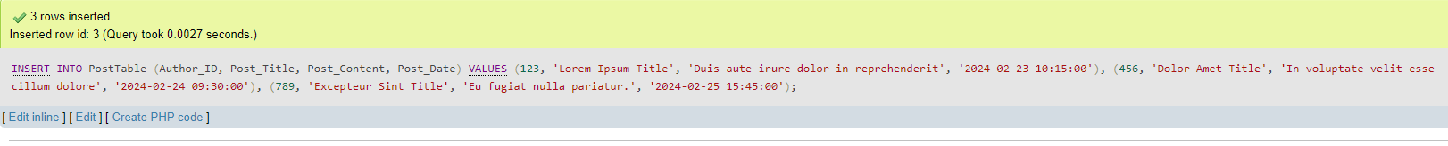(789, 'Excepteur Sint Title', 'Eu fugiat nulla pariatur.', '2024-02-25 15:45:00');

Now I am able to delete the first 2 rows.

DELETE Authors, Posts, Comments

FROM AuthorsTable AS Authors

LEFT JOIN PostTable AS Posts ON Authors.Author_ID = Posts.Author_ID

LEFT JOIN Comments ON Posts.Post_ID = Comments.Post_ID

WHERE Authors.Author_ID IN (123, 456);

